|  |  |  |  |  |  |
| --- | --- | --- | --- | --- | --- |
|  |  |  |  |  | logo1.png |

|  |  |  |  |
| --- | --- | --- | --- |
| Course Name | | Graphic design(canva) | |
| College Name | | Mangayarkarasi College of Arts and Science for Women Paravai, Madurai - 625002 | |
| College Code | | MKU251 | |
| Skill Offering Id | | 0EC49DE406E5D1CB54B4C8813AE877C0 | |
| Project Title | | Designing professional business card | |
| Project Submitted To | | Madurai Kamaraj University ( Naan Mudhalvan Scheme(TNSDC)) | |
| Year | | 2023 | |
| Department | | B.A ENGLISH | |
| Semester | | 5 | |
| Group Number | | 1 | |
| Total Members of the Group | | 4 | |
| Group Members Details | | | |
| Name of the Member | University Register. No | | Student NM ID |
| 1. PREETHI KRISHNA. P | C1A17437 | | 0EC49DE406E5D1CB54B4C8813AE877C0 |
| 1. AARTHI. D | C1A17401 | | 3097D8FD4867396A89644D43D4BAC927 |
| 1. ABARNA. S | C1A17403 | | 65BDE71A3F2C16894B14EDE8C849A4F8 |
| 1. ABARNADEVI. M | C1A17404 | | F04CBC268272ADC94DE4AE4030CB4384 |
|  |  | |  |
| Under the Guidance | | DR. MEENA | |
| SPOC | | Ms.P.UMADEVI | |

**DESIGNING PROFESSIONAL BUSINESS CARD**

**1.Introduction.**

***1.1 Overview***

**A business card typically includes the giver's name, company or business affiliation (usually with a logo) and contact information such as street addresses, telephone number(s), fax number, e-mail addresses and website. Before the advent of electronic communication, business cards also included telex details. Contact Information. Perhaps the most important aspect of any business card is all of the necessary contact information a potential client needs in order to get in touch with you..**

***1.2 Purpose***

**The purpose of a business card is to create an awareness of what you do to your prospective clients. Only include the most important information that can direct the recipient to learn more about your profession or company by visiting your website or using the contact information, such as: Your name. Company name, business card is a highly personal form of marketing, and does exactly what you need it to. Business cards serve the key purpose of marketing your business and getting your key contact information into your client's hands… all in a matter of seconds. Fundamental to the value of the business card, is its portability.**

1. **Problem Definition and Design Thinking**
   1. Empathy Map

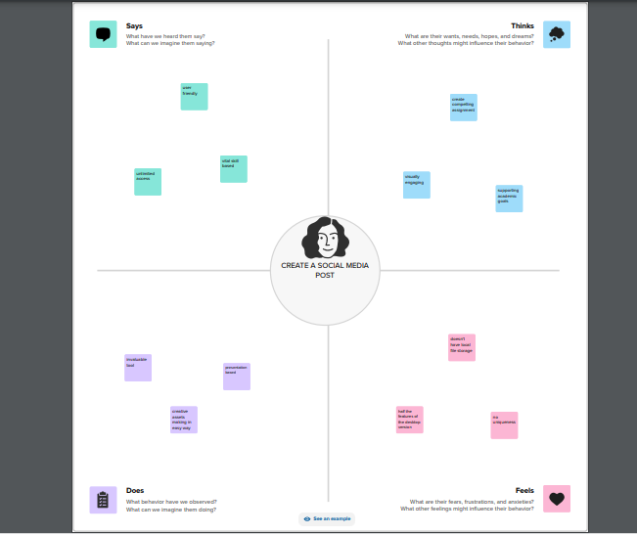

**2.2 Ideation and Brainstroming Map**

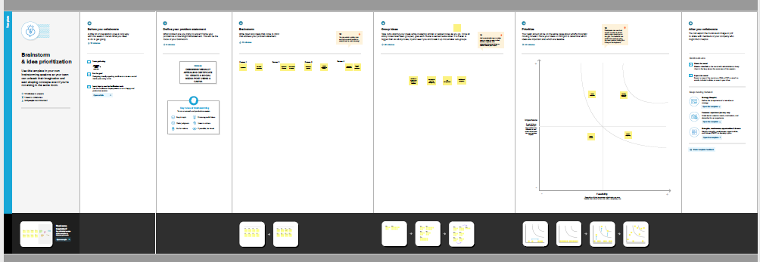

1. **Result:**

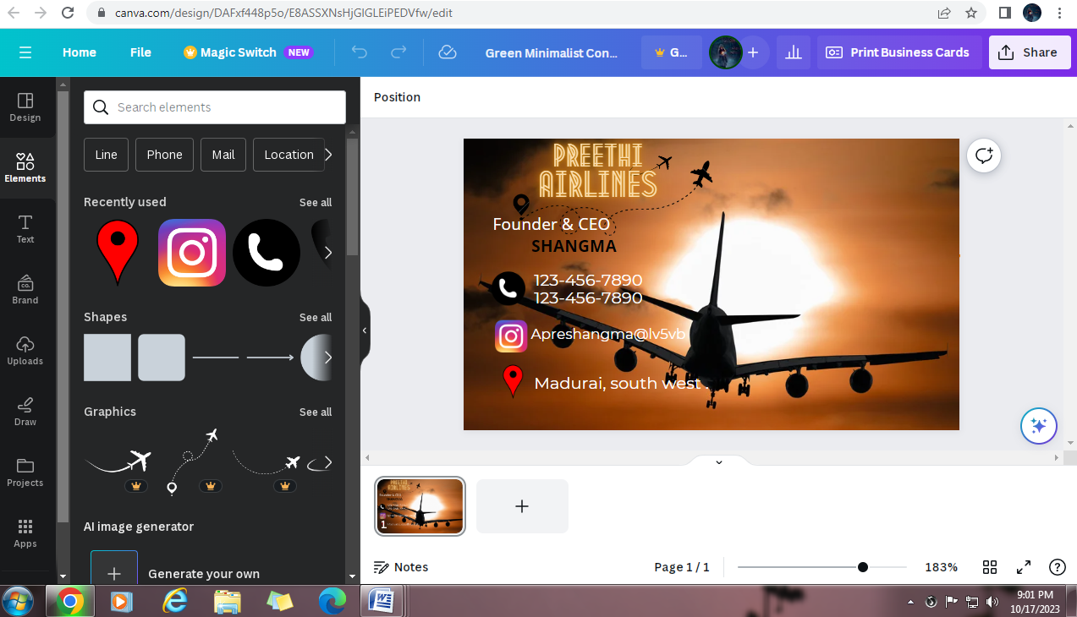

**MILESTONE 1:**

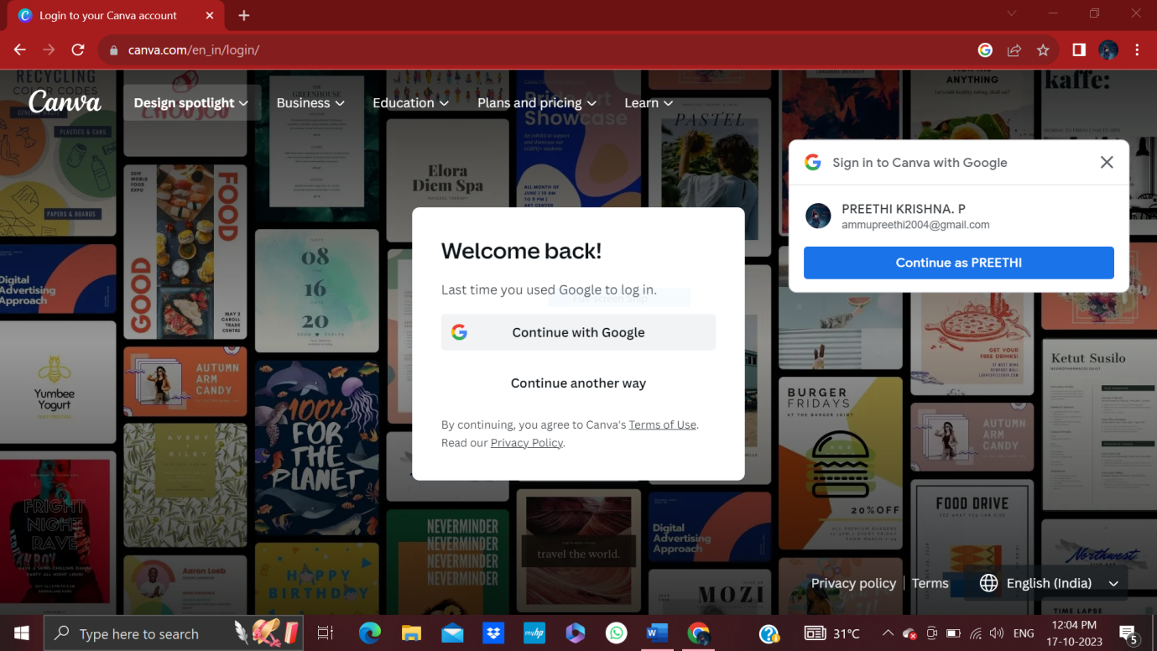

**MILESTONE 2:**

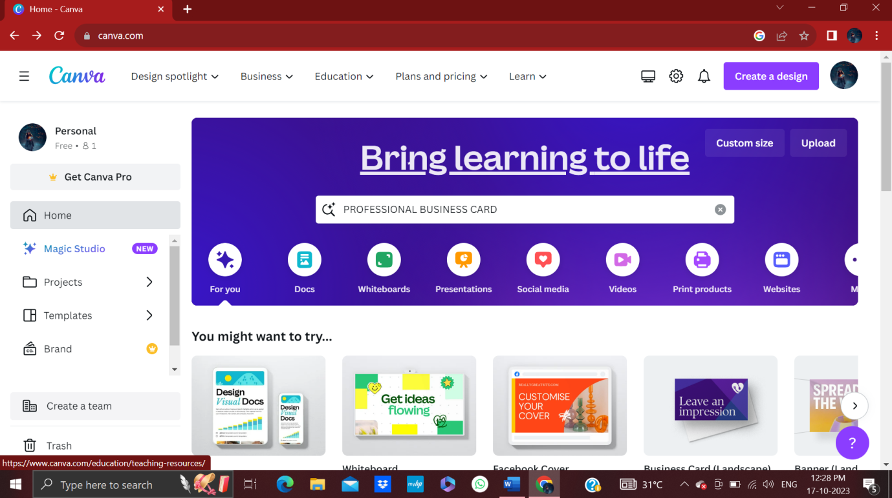

**MILESTONE 3:**

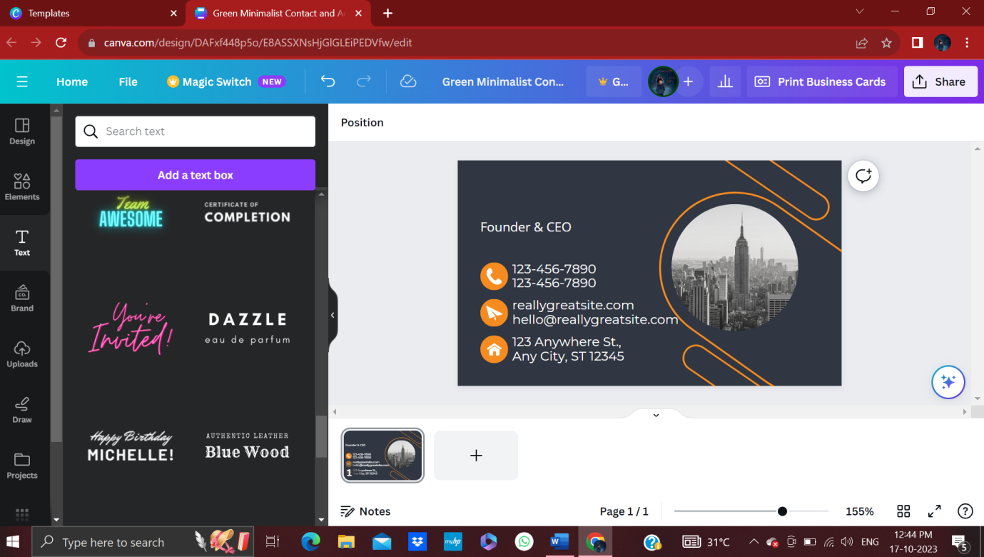

**MILESTONE: 4**

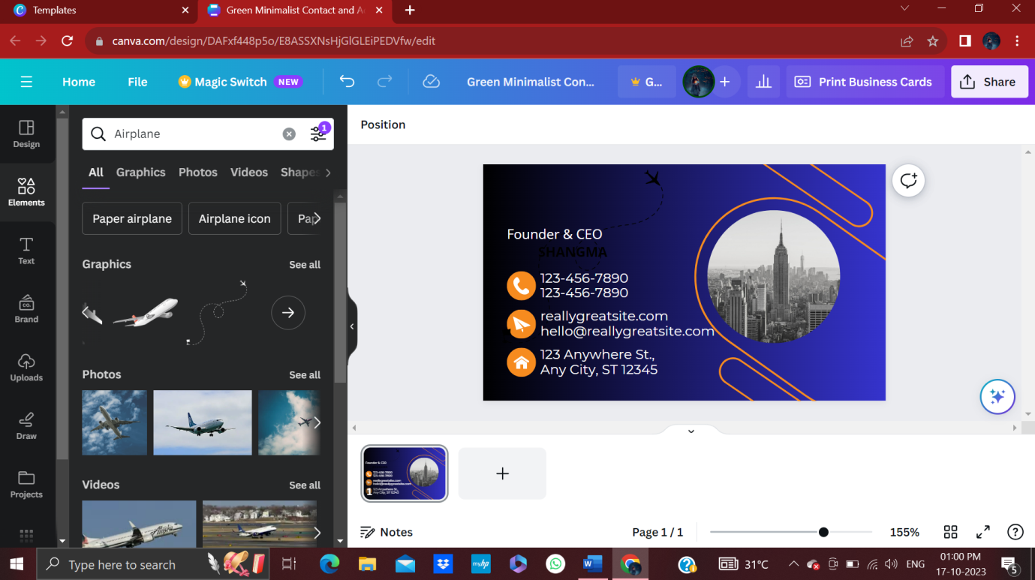

**MILESTONE:5**

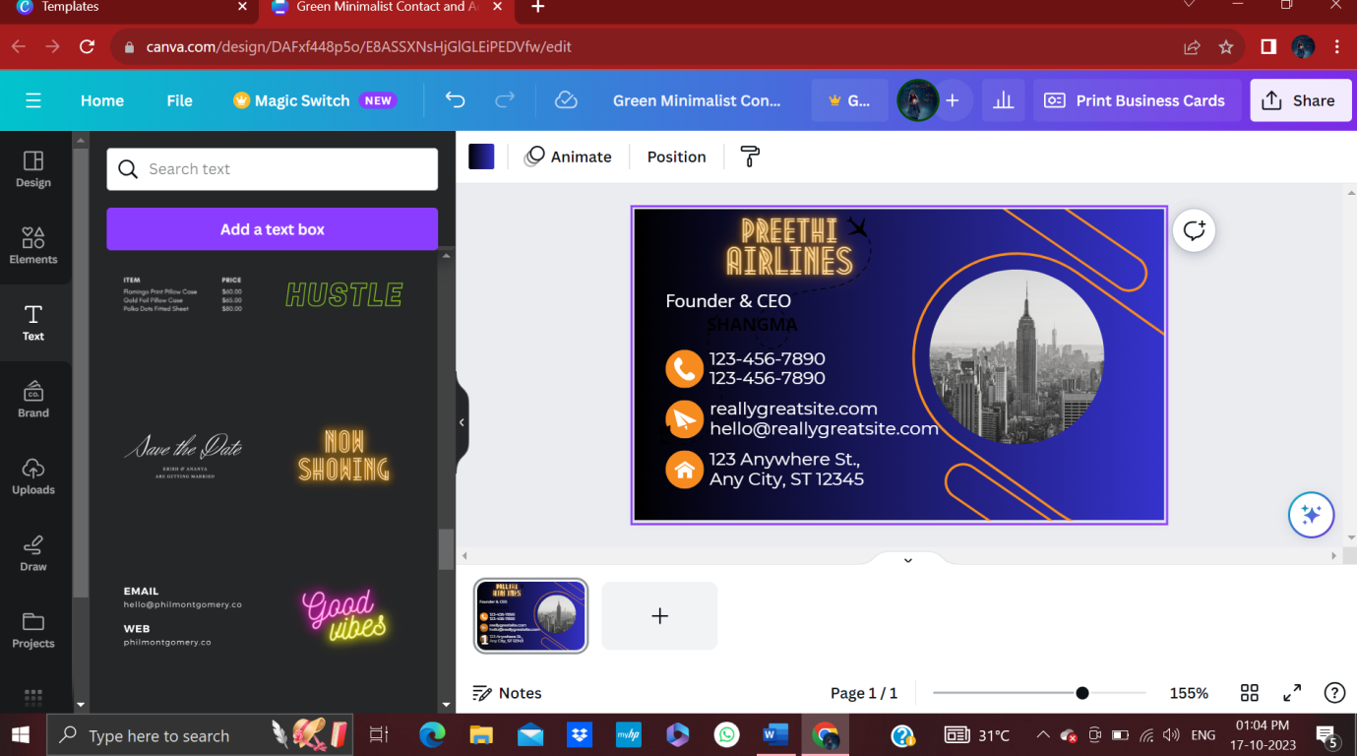

MILESTONE:6

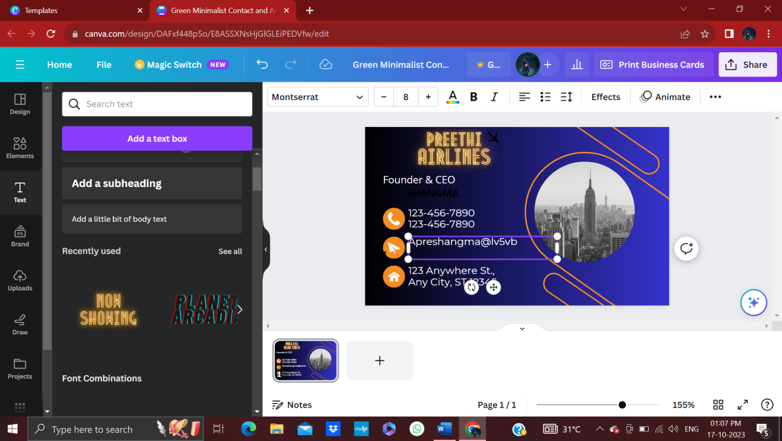

MILESTONE:7

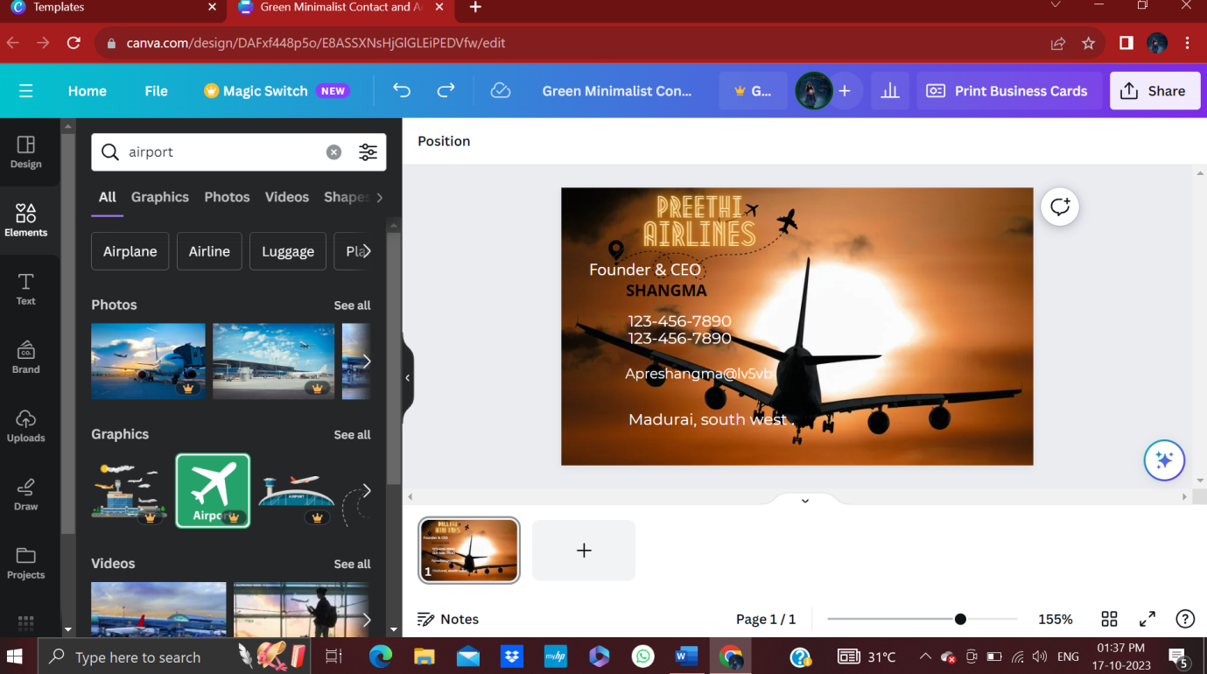

**MILESTONE:8**



***4. Advantages :***

* + - * **Browse ready-made templates. Not sure where to start? ...**
      * **Personalize your design. Create a business card that truly represents you.**
      * **Get creative with more design ingredients. Explore millions of icons, illustrations, images, and fonts.**
      * **Order your prints.**

***Disadvantages:***

* Limitation of number of templates.
* Alignment concerns.
* Export settings are limited.
* Cannot download the “raw” file to your computer.
* Free version is limited.

1. **Conclusion:**

Canva free business card creator makes it easy to brand your business card. Upload your logo, use your brand colors, and choose complementary fonts to showcase your brand's look and feel. Business cards offer businesses and individuals a convenient and cost-effective way to save money when networking. You can quickly exchange contact information using digital business cards without relying on environmentally polluting printing

1. **Future scope:**

In the future, Canva is a popular, simple online graphic design tool. Users can import images, use templates to design banners and logos, or pay to use Canva's premium stock images/paid templates. All free photos, music, and video files can be used for free for commercial or non-commercial purposes. Canva is an interesting platform where users can earn some extra cash through their design skills. Canva has a marketplace where users can sell their designs to other Canva users. If you have strong design skills, you can create and sell designs on the marketplace to earn money. You can set your prices and earn a commission each time someone purchases your design.If your template design includes Pro Content, you must keep the template within Canva. Meaning, you can only sell the template as a shareable link that directs users back to Canva, not as an off-platform, downloadable file. This ensures all royalties are paid to Canva's creators.